

Vigo Lane, Rickleton, Washington, Tyne & Wear. NE38 9EZ
Telephone: 0191 415 5050
Headteacher: J Price Deputy Headteacher: A Baker
Email: info@rickletonprimary.co.uk www.rickletonprimary.co.uk

7th January 2026
Dear Parent/Carers,
KS2 Revision guides
To support your child with preparing for the end of KS2 assessments (SATS), we would recommend purchasing revision guides to use at home. The supplier is able to give the school a significant discount on prices which we are able to pass on to yourselves; the school does not gain anything from selling the books.
There are several options available:
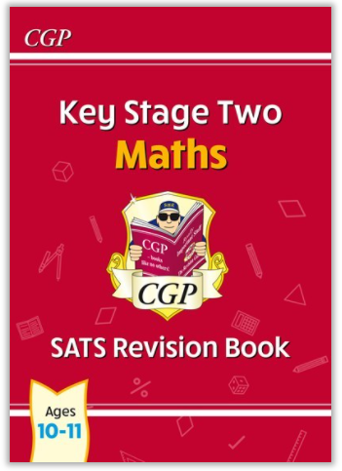KS2 SATS Revision Book Maths £2.95 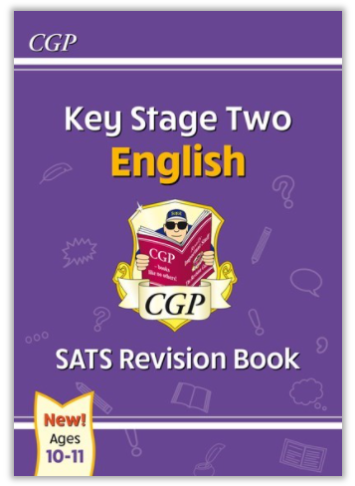 KS2 SATS Revision Book English £2.95
Complete KS2 Maths and English 10 minutes test SAT buster bundle. £6.95

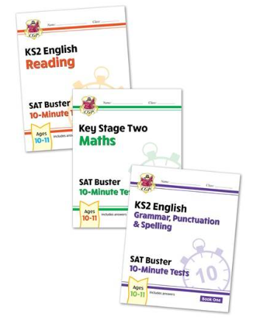
Please return the form below indicating your choice by Wednesday 14th January. The method of payment is via SchoolMoney. Once we receive all orders, a link for the payment will be uploaded to SchoolMoney for payment by 19th January. Orders will be placed following receipt of payment. We are able to offer the books half price for children in receipt of Free School Meals. Please let Mrs Hubbick in the School Office know if you would like to receive this discount.
We strongly encourage you to purchase these revision guides as they will support your child with their home revision and preparation for the SATs. Please do not hesitate to contact class teacher should you have any queries regarding the guides.
Yours sincerely
Mrs Couling and Mrs Dhinsa
-----------------------------------------------------------------------------------------------------------------------------------KS2 Revision guides
Name of child: ___________________________________________ Class: ______________
KS2 SATS Revision Book Maths @ £2.95
KS2 SATS Revision Book English @ £2.95
Complete KS2 Maths and English 10 minutes test SAT buster bundle £6.95
Signed (Parent/ Carer): _____________________________ Dated: __________

