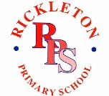

Vigo Lane, Rickleton, Washington, Tyne & Wear. NE38 9EZ
Telephone: 0191 415 5050
Head Teacher: J Price
Email: info@rickletonprimary.co.uk www.rickletonprimary.co.uk

Parents’ Evenings – Monday 16th February and Wednesday 18th February 2026
Dear Parents and Carers,
Parents’ evenings for the Spring term will be held on Monday 16th February and Wednesday 18th February 2026 from 3.40pm onwards. For Nursery Rainbow class the appointments will be available from 2pm on those days. New Rising Rainbow pupils will receive a mini report, rather than a parents evening slot. For Honey class, class teachers will be holding their appointments on their normal day in school, so on Monday it will be Mrs S O’Connor and Mrs K O’Connor will be on Wednesday.
As we did last year, we are going to be using an online booking system. Please note that we are only able to offer one appointment per child.
A link will be sent via text and/or email which will take you to the online booking system. To make an appointment for a face-to-face meeting in school please follow the instructions below.
The text and/or email message will be sent at 6pm on Monday 19th January.
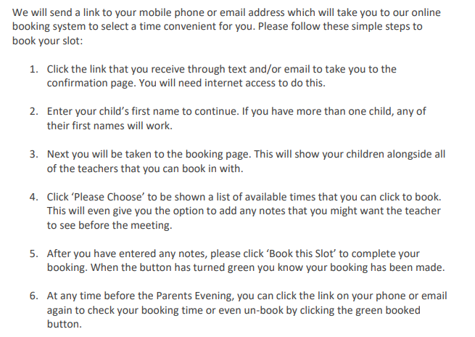

Please note that the online booking system will close on Monday 9th February.
Thank you
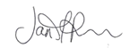
Mrs J Price

Headteacher

